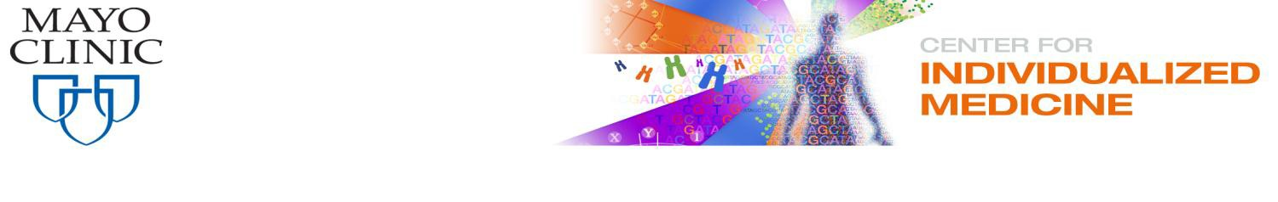

Nicholas Chia

Mayo Clinic

200 First St SW

Rochester, MN 55905

March 5th, 2019

**Principal Investigator:** Leigh Greathouse, PhD, MPH, MS, RD

**Co-I:** Nicholas Chia, Ph.D.

**RE:** Illuminate Proposal

Dear Review Committee,

As Co-Director of the Microbiome Program and Associate Professor of Biophysics in the Center for Individualized Medicine, I fully endorse the proposed study **Development of precision medicine prebiotics using mini-bioreactor arrays (MBRAs)**.

Our laboratory is interested in understanding how the gut microbiome influences colon cancer risk and development. Specifically, we are focused on manipulating the gut microbiome using antibiotics, probiotics or prebiotics to determine how to attenuate risk. My research uses metabolic modeling to understand complex microbial interactions to better understand the mechanisms controlling risk. Thus, I am thrilled to have the opportunity to be a part of this study and assist Dr. Greathouse and Baylor University in establishing the MBRA system. As the developer of several metabolic modeling software tools, I have expertise in all aspects of modeling of the data generated from this research, which makes me well-suited to serve as Co-Principal Investigator on this Illuminate Proposal. Overall, our research is complimentary and potentially synergistic with that of Dr. Greathouse.

The results from this study will lay the ground work for a larger multi-phase study that is well-positioned to address the need for prebiotic formulations and treatments to combat infections. Ultimately, this research will lead to a deeper understanding of the dietary prebiotic fibers that modulate the gut microbiome, and identify the prebiotics that support microbial communities capable of both resistance to and eviction of pathogens.

I have little doubt that this project will develop into a highly impactful long-term collaboration with exceptional external funding opportunities from multiple agencies, and that will generate innovative research on the diet-microbiome relationship. Overall, I am well positioned to provide excellent support for this study and we look forward to collaboration to facilitate Baylor’s mission of R1 Status.

Sincerely,



Nicholas Chia, Ph.D.

200 First Street SW/Harwick 3